**FRIO COUNTY COMMISSIONERS COURT MINUTES FOR**

**Regular Meeting February 14, 2023**

On the 14th day of February, 2023, at 3:00 p.m., the Commissioners Court of Frio County met in a special meeting with the following members either absent or present, to-wit: Rochelle Lozano Camacho, Frio County Judge was present; Joe Vela, Commissioner Pct 1 present; Mario Martinez, Commissioner Pct 2 absent; Raul Carrizales , Commissioner Pct 3 present; Danny Cano, Commissioner Pct 4 present; Joseph A. Sindon, Legal Counsel for Frio County Commissioners Court present; and Aaron Ibarra, Frio County Clerk present when the following meeting was held, to-wit:

I. Invocation and Pledge of Allegiance

II. Adopt Agenda

MOTION: COMMISSIONER RAUL CARRIZALES

SECOND: COMMISSIONER MARIO MARTINEZ

MOTION PASSED

III. Old Business

**PRESENTATION**

**ACTION AGENDA ITEMS**

IV. General Discussion

V. Citizens To Be Heard

Laura Dominguez

*Please note that the Rules of Procedure, Conduct and Decorum at Meetings of the Commissioners Court of Frio County, Texas limit each speaker to a maximum of three (3) minutes to make his or her remarks. Inappropriate conduct or comments during this time, including but not limited to disruptive behavior, insults, personal attacks, and inappropriate language, may result in the speaker being ordered to leave the meeting and forfeit any remaining speaking time. For more information regarding the above-mentioned rules, please see the complete Rules of Procedure, Conduct and Decorum at Meetings of the Commissioners Court of Frio County, Texas, which is available upon request.*

VI. New Business

**PRESENTATION**

**ACTION AGENDA ITEMS**

(1) Denise Woody, Business Administrator, Frio County Emergency Services District Number 1, requests:

Consider/take action on reappointing Chico Hines and Linda Parsons to their currently held positions on the Frio County ESD Board.

MOTION: COMMISSIONER RAUL CARRIZALES

SECOND: COMMISSIONER JOE VELA

MOTION PASSED

(2) Mona Hoyle, requests:

Consider/take action on waiving the park rental fees of $75.00 for using Fireman’s Park to host Frio Pioneer Days related activities on March 25, 2023.

MOTION: COMMISSIONER RAUL CARRIZALES

SECOND: COMMISSIONER MARIO MARTINEZ

MOTION PASSED

(3) Hon. Aaron Ibarra, Frio County Clerk, requests:

3.1 Review Frio County Commissioners Court minutes for January 23 and 27, 2023

3.2 Consider/Approve Frio County Commissioners Court minutes for January 23 and 27, 2023

MOTION: COMMISSIONER RAUL CARRIZALES

SECOND: COMMISSIONER MARIO MARTINEZ

MOTION PASSED

(4) Hon. Mike Morse, Frio County Sheriff, requests:

4.1 Consider/take action on approving a Quote and Standard Terms and Conditions with LumenServe for a Frio County Tower Data Plan at a rate of $9.00 per month.

4.2 If the agreement is approved, then sign a resolution authorizing Frio County Judge Arnulfo C. Luna to enter into said contract on behalf of Frio County.

MOTION: COMMISSIONER RAUL CARRIZALES

SECOND: COMMISSIONER MARIO MARTINEZ

MOTION PASSED

(5) Hon. Mike Morse, Frio County Sheriff, requests:

5.1 Consider/take action on signing a resolution changing the authorized official for Frio County for the LoneStar Grant #4384701 from Hon. Arnulfo C. Luna to Hon. Rochelle Camacho.

MOTION: COMMISSIONER RAUL CARRIZALES

SECOND: COMMISSIONER MARIO MARTINEZ

MOTION PASSED

5.2 Consider/take action on signing a resolution changing the authorized official for Frio County for the Stone Garden Grant #4384805 from Hon. Arnulfo C. Luna to Hon. Rochelle Camacho.

MOTION: COMMISSIONER RAUL CARRIZALES

SECOND: COMMISSIONER MARIO MARTINEZ

MOTION PASSED

5.3 Consider/take action on signing a resolution changing the authorized official for Frio County for the Rifle-Resistant Body Armor Grant #4415801 from Hon. Arnulfo C. Luna to Hon. Rochelle Camacho.

MOTION: COMMISSIONER RAUL CARRIZALES

SECOND: COMMISSIONER MARIO MARTINEZ

MOTION PASSED

(6) Hon. Mike Morse, Frio County Sheriff, requests:

Consider/take action on approving a resolution authorizing the Frio County Sheriff’s Office to apply for the Project Safe Neighborhoods Grant Program.

MOTION: COMMISSIONER DANNY CANO

SECOND: COMMISSIONER JOE VELA

MOTION PASSED

(7) Hon. Mike Morse, Frio County Sheriff, requests:

Consider/take action on approving an increase in the monthly spending limit of the Frio County Sheriff’s Office / Frio County Sheriff’s Office Jail purchasing credit card from the current amount to $20,000.00.

(8) Hon. Mike Morse, Frio County Sheriff, requests:

Discuss and approve the purchase of fifteen (15) handheld portable radios for an estimated cost of $56,601.08 utilizing the ARP emergency management budget line item.

MOTION: COMMISSIONER MARIO MARTINEZ

SECOND: COMMISSIONER DANNY CANO

MOTION PASSED

(9) Hon. Rochelle Camacho, Frio County Judge, requests:

Consider/take action on determining that the pipeline crossings placed under county roads 3329, 3715, 3857, 4440, 4515, 4743, and 4757 by Gray Oak Pipeline, LLC are complete and authorize the sending of a letter releasing the company of their requirement to provide bonds covering the construction of those pipeline crossings.

(10) Hon. Crystal Marquez, Frio County Auditor, requests:

10.1 Consider / take action on six (6) new Toshiba e-Studio-3528A copiers for the Frio County Clerk, County Extension Agent, County Auditor, County Treasurer, County Commissioners Court, and County Sheriff’s Office for $913.56 per month for a 60-month lease. This is state approved on the DIR-CPO-4426 contract.

10.2 If approved, consider/take action on signing resolution authorizing Judge Rochelle Camacho to sign approved agreement on behalf of Frio County.

MOTION: COMMISSIONER RAUL CARRIZALES

SECOND: COMMISSIONER MARIO MARTINEZ

MOTION PASSED

(11) Hon. Crystal Marquez, Frio County Auditor, requests:

Consider/take action on waiving the probationary period for Blue Cross Blue Shield of Texas health insurance benefits for Frio County WIC new employee Elodia Peralta.

MOTION: COMMISSIONER RAUL CARRIZALES

SECOND: COMMISSIONER MARIO MARTINEZ

MOTION PASSED

(12) Hon. Crystal Marquez, Frio County Auditor, requests:

12.1 Consider / take action on approving an Information Technology Support and Maintenance Agreement between Frio County and Holguin Technology Services, Inc. for $4,000.00 per month

12.2 If the agreement is approved, then approve and sign a resolution authorizing Hon. Rochelle Camacho, Frio County Judge to execute the agreement on behalf of Frio County.

MOTION: COMMISSIONER JOE VELA

SECOND: COMMISSIONER DANNY CANO

MOTION PASSED

(13) Hon. Crystal Marquez, Frio County Auditor, requests:

Consider/take action on signing the Affidavit HDM County Grant Program Year 2022 authorizing that Frio County paid the grant amount of $4,392.50 to the Home Delivered Meal Grant Program run by the Texas Department of Agriculture.

MOTION: COMMISSIONER RAUL CARRIZALES

SECOND: COMMISSIONER DANNY CANO

MOTION PASSED

(14) Hon. Crystal Marquez, Frio County Auditor, requests:

14.1 Consider/take action on approving a Replace Upon Failure Agreement between Frio County and AEP Texas.

14.2 If the agreement is approved, then approve and sign a resolution authorizing Hon. Rochelle Camacho, Frio County Judge to execute the agreement on behalf of Frio County.

MOTION: COMMISSIONER RAUL CARRIZALES

SECOND: COMMISSIONER MARIO MARTINEZ

MOTION PASSED

(15) Hon. Crystal Marquez, Frio County Auditor, requests:

15.1 Consider / take action on approving the credit application with Texas Fueling Services Inc.

15.2 If the application is approved, then approve and sign a resolution authorizing Hon. Rochelle Camacho, Frio County Judge to execute the agreement on behalf of Frio County.

MOTION: COMMISSIONER MARIO MARTINEZ

SECOND: COMMISSIONER DANNY CANO

MOTION PASSED

(16) Hon. Crystal Marquez, Frio County Auditor, requests:

Discuss and/or take appropriate action to certify the revenue received, $59,253.48 under the General Fund (fund 100) and add the following line items to the 2022-2023 Budget to receipt the funds and allow expenses:

Account #: 100-40000.4373 CHAPTER 19-ELECTIONS

Account Name: REVENUES

Account #: 100-54504.5119 SALARIES-PART TIME

Account Name: ELECTIONS

Account #: 100-40000.4866 PROCEEDS INSURANCE CLAIMS

Account Name: REVENUES

Account #: 100-57207.5220 PURCHASES NON-CAPITALIZE

Account Name: SHERIFF

Account #: 100-40000.4898 DONATIONS

Account Name: REVENUES

Account #: 100-57207.5291 DONATIONS

Account Name: SHERIFF

MOTION: COMMISSIONER RAUL CARRIZALES

SECOND: COMMISSIONER DANNY CANO

MOTION PASSED

(17) Hon. Crystal Marquez, Frio County Auditor, requests:

17.1 Consider / take action to approve the budget amendments to the FISCAL YEAR 2022-2023 Frio County Budget, list below:

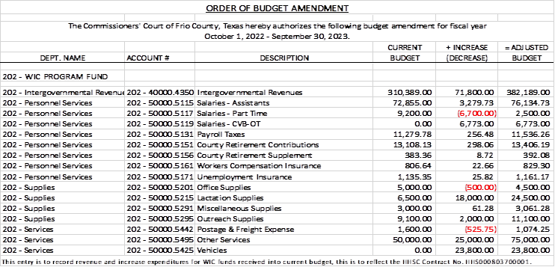

17.2 If the amendment is approved, consider/take action on signing order stating same.

MOTION: COMMISSIONER MARIO MARTINEZ

SECOND: COMMISSIONER RAUL CARRIZALES

MOTION PASSED

(18) Hon. Crystal Marquez, Frio County Auditor, requests:

18.1 Consider / take action to approve the budget amendments to the FISCAL YEAR 2022-2023 Frio County Budget, list below:

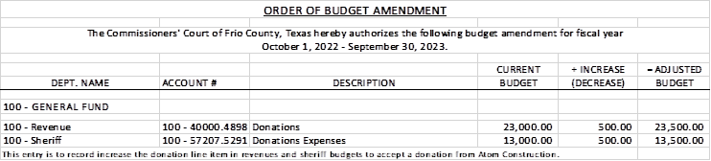

18.2 If the amendment is approved, consider/take action on signing order stating same.

MOTION: COMMISSIONER RAUL CARRIZALES

SECOND: COMMISSIONER DANNY CANO

MOTION PASSED

(19) Hon. Crystal Marquez, Frio County Auditor, requests:

19.1 Consider / take action to approve the budget amendments to the FISCAL YEAR 2022-2023 Frio County Budget, list below:

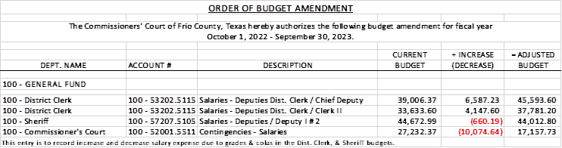

19.2 If the amendment is approved, consider/take action on signing order stating same.

MOTION: COMMISSIONER RAUL CARRIZALES

SECOND: COMMISSIONER MARIO MARTINEZ

MOTION PASSED

(20) Hon. Crystal Marquez, Frio County Auditor, requests:

20.1 Consider / take action to approve the budget amendments to the FISCAL YEAR 2022-2023 Frio County Budget, list below:

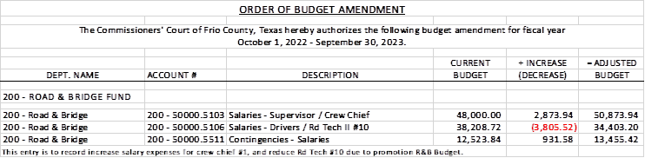

20.2 If the amendment is approved, consider/take action on signing order stating same.

MOTION: COMMISSIONER MARIO MARTINEZ

SECOND: COMMISSIONER JOE VELA

MOTION PASSED

(21) Hon. Crystal Marquez, Frio County Auditor, requests:

Consider / take action on using ARP eligible expenses to approve quote #Q0003335 from Plum Laboratories Inc., to purchase XTD0005 Plum Extended 5G-Ready Dual Modem w/PPB, including Plum Care Annual Service to be utilized by the Sheriff’s Office for a total cost of $11,905.36.

MOTION: COMMISSIONER RAUL CARRIZALES

SECOND: COMMISSIONER MARIO MARTINEZ

MOTION PASSED

(22) Hon. Rochelle Camacho, Frio County Judge, requests:

22.1 Consider/take action on approving a Pop-Up Distribution Program Agreement between the San Antonio Food Bank and Frio County.

22.2 If the agreement is approved, consider/take action on signing resolution authorizing Hon. Rochelle Camacho, Frio County Judge, to sign same on behalf of Frio County.

MOTION: COMMISSIONER RAUL CARRIZALES

SECOND: COMMISSIONER DANNY CANO

MOTION PASSED

(23) Hon. Daniel Zapata, Frio County Constable, Precinct Number 3, requests:

Consider/take action on using ARP funds for the purchase of a new transmission for the patrol unit for the Frio County Precinct Number 3 Constable Patrol Unit for a cost of approximately $5,500.00.

(24) Tommy Navarro, Frio County Facilities Department Supervisor, requests

24.1 Consider/take action on executing a contract with UniFirst Corporation.

24.2 If the agreement is approved, then sign a resolution authorizing Frio County Judge Rochelle Camacho to enter into said agreement on behalf of Frio County.

MOTION: COMMISSIONER DANNY CANO

SECOND: COMMISSIONER JOE VELA

MOTION PASSED

(25) Tommy Navarro, Frio County Facilities Department Supervisor, requests

Execute ADT Commercial Proposal between Frio County and ADT for the installation and monitoring of security devices at the Frio County Building Improvement Project located at 1796 IH 35 E, Pearsall, Texas.

(26) Roxana Garcia, P.E., Frio County Engineer, requests:

26.1 Consider / take action on approving new construction online application agreement with Medina Electric including an engineering fee of $100.00 to add new services at the Moore Community Center located at 647 County Road 1543, Moore, Texas

26.2 If the application is approved, then approve and sign a resolution authorizing Hon. Rochelle Camacho, Frio County Judge, to execute the application on behalf of Frio County.

(27) Roxana Garcia, P.E., Frio County Engineer, requests:

Approve waiving the park rental fee of $75 for Fireman’s Park for Medical benefit held by Melody G. Reyes.

MOTION: COMMISSIONER RAUL CARRIZALES

SECOND: COMMISSIONER JOE VELA

MOTION PASSED

(28) Roxana Garcia, P.E., Frio County Engineer, requests:

Approve waiving the park rental fee of $75 for Frio County Regional Park for Medical benefit held by Adan Vela.

MOTION: COMMISSIONER DANNY CANO

SECOND: COMMISSIONER RAUL CARRIZALES

MOTION PASSED

(29) Roxana Garcia, P.E., Frio County Engineer, requests:

Approve extending the park rental hours for Fireman’s Park for the Knights of Columbus.

MOTION: COMMISSIONER DANNY CANO

SECOND: COMMISSIONER RAUL CARRIZALES

MOTION PASSED

(30) Roxana Garcia, P.E., Frio County Engineer, requests:

30.1 Discuss approving the final subdivision plat for the Frio County Estates Subdivision to be filed for record in the Frio County Clerk’s Office. Specifically, discuss whether the requirements of the Fifth Revised Edition of the Frio County Standards for Subdivisions have been met.

30.2 If all requirements have been met, sign resolution stating same, then authorize the filing and recording of the plat with the Frio County Clerk after proper acknowledgment.

MOTION: COMMISSIONER MARIO MARTINEZ

SECOND: COMMISSIONER DANNY CANO

MOTION PASSED

(31) Roxana Garcia, P.E., Frio County Engineer, requests:

31.1 Consider/take action on approving Work Authorization No.1 between Frio County and Aguirre & Fields for engineering services (construction inspection and management) for the Frio County Bridge Replacement project on CR 2410/San Miguel Road and CR 3314/E. Goldfinch Rd.

31.2 If the work authorization is approved, consider/take action on signing a resolution authorizing Hon. Rochelle Camacho, Frio County Judge to execute same on behalf of Frio County.

MOTION: COMMISSIONER RAUL CARRIZALES

SECOND: COMMISSIONER MARIO MARTINEZ

MOTION PASSED

(32) Roxana Garcia, P.E., Frio County Engineer, requests:

Consider/take action on opening bids received by the specified deadline for debris removal from bridge No. 15-083-Aao1-56-003 on CR 1301/Yancey Rd. over Hondo Creek and select a winning bid from bid received.

(33) Roxana Garcia, P.E., Frio County Engineer, requests:

33.1 Consider/take action on approving an Underground Utility Permit between Frio County and Zachary Mann for a 10-inch steel waterline and a 1-1/2 inch electrical conduit to be installed under CR 3614/Henry Mann Rd.

33.2 If the permit is approved, consider/take action on approving a resolution authorizing Hon. Rochelle Camacho, Frio County Judge, to sign same on behalf of Frio County.

MOTION: COMMISSIONER MARIO MARTINEZ

SECOND: COMMISSIONER RAUL CARRIZALES

MOTION PASSED

(34) Hon. Rochelle Camacho, Frio County Judge, requests:

34.1 Consider/take action on accepting the resignation of the Frio County Human Resources Director.

34.2 Consider/take action on approving job description listings for the Frio County Human Resources Director.

34.3 If approved, consider/take action on advertising the job opening.

MOTION: COMMISSIONER MARIO MARTINEZ

SECOND: COMMISSIONER RAUL CARRIZALES

MOTION PASSED

(35) Frio County Commissioners Court, requests:

Receive in person from the following county officials the following reports as mandated by law:

35.1 Presentation by Frio County Treasurer of detailed report as mandated by Section 114.026, Local Government (“Code”) (this report is to be presented at each **regular term of commissioners court).**

35.2 Frio County Treasurer to exhibit the books and accounts of that office for the inspection of the commissioners court (**to be done at each regular term of commissioners court).**

35.3 Consider/take action on authorizing the execution by Frio County Commissioners Court (the Judge and each commissioner) of an affidavit stating the requirements of the treasurer’s report have been met as mandated by section 114.026 of the Code.

MOTION: COMMISSIONER RAUL CARRIZALES

SECOND: COMMISSIONER MARIO MARTINEZ

MOTION PASSED

35.4 Consider/take action on execution of an order of the commissioners court approving the county treasurer’s report and order their publication in the Frio-Nueces Current as mandated by Section 114.026 of the Code or publication on the county’s website.

MOTION: COMMISSIONER RAUL CARRIZALES

SECOND: COMMISSIONER MARIO MARTINEZ

MOTION PASSED

(36) Frio County Commissioners Court requests:

Presentation, pursuant to Section 114.044 of the Local Government Code, by:

1. Frio County District Clerk;

2. Frio County Clerk

3. Frio County Treasurer

4. Frio County Attorney

5. Frio County Judge

6. Frio County Sheriff

7. Frio County Auditor

8. Frio County Justice of the Peace

9. Frio County Constables

**(who collects or handles any money for the use of the county) of all fines imposed, judgments rendered and collected, and all jury fees collected by the respected courts in favor of or for the use of the county and at that time when the reports are presented to present receipts vouchers that show disposition of the money, fines or judgments.**

After examination by the commissioners court as to the correctness of the reports, consider/action on directing the county clerk to enter information in county finance records as mandated by Section 114.044 of the Code.

MOTION: COMMISSIONER RAUL CARRIZALES

SECOND: COMMISSIONER DANNY CANO

MOTION PASSED

(37) Documents (resolutions, orders, contracts, etc.) to be signed.

(38) Allow bills payable

MOTION: COMMISSIONER MARIO MARTINEZ

SECOND: COMMISSIONER JOE VELA

MOTION PASSED

(39) Adjourn

MOTION: COMMISSIONER RAUL CARRIZALES

SECOND: COMMISSIONER DANNY CANO

MOTION PASSED